* 1. ShurjoPay Setup

After logged in go to setup->Payment->Payment Gateways

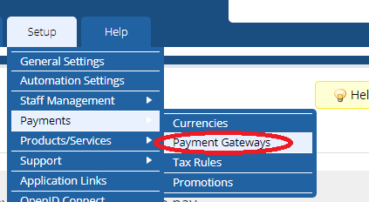

* 1. Select “shurjoPay ” from All Payment gateways

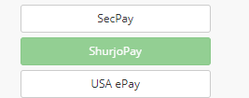

* 1. Go to Manage Existing Gateways and follow the below instruction

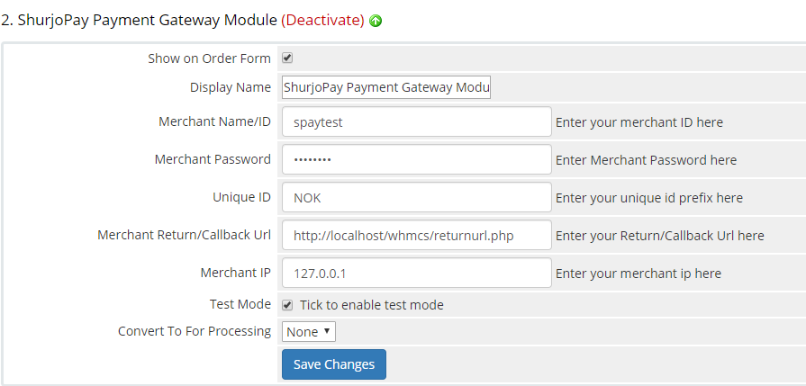

1. Show on Order Form set it
2. Display Name: set it as provided by shurjoMukhi limited. I.e spaytest
3. Merchant Password: set it as provided by shurjoMukhi limited. I.e pass1234
4. Unique ID: set it as provided by shurjoMukhi limited. I.e: NOK
5. Merchant Return/Callback Url: Enter your Return/Callback Url here
6. Merhant IP: Enter your merchant ip here
7. Test Mode: checked if you are testing the gateway. Mention that exaple user password will work in test mode.
8. Convert To For Processing: set it according to your need.[1]

1.